certificate of attendance

SALTO E&T Resource Centre hereby certifies that

…………………(name)…………………..

(NA code)

attended the following modules of the online annual TCA officers’ week:

- Newcomer TCA officer induction training
- SALTO Platform developments’ training
- Official opening and networking
- Strategic Planning on LTAs
- Policy transfer and closing

The event was organised between 23-30 September 2021.

Budapest, 15. October 2021.

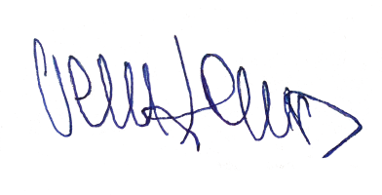

MR. ISTVÁN VERSES
Head of Erasmus+ Department
Tempus Public Foundation

