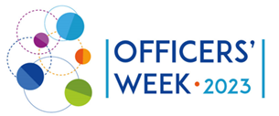
AGENDA
Community matters for community matters!
12-14 SEPTEMBER 2023 | ZOOM

24 May | Online
9.00–12.30

21 June | Online

5 June | Monday | Arrivals
16.00–18.30

6 June | Tuesday | Day 1
13.30–16.00
18.30

7 June | Wednesday | Day 2
9.30–12.00
13.00–16.00
18.30 | - Networking programme

8 June | Day 3 | Departures
9.30–12.00 | Aim: Participants will have the possibility to listen to the programme novelties from the representative of the European Commission and raise their questions. In the afternoon session useful TCA practices will be presented for each other’s inspiration.  - Presentation of the European Commission  - Q&A session  - Burning issues discussion in groups
13.00–16.00 | - Useful practice presentations - Unforgettable moments  - Working Group’s corner  - Summary and closing of the meeting
16.15–17.45 | - LTA community meeting (for LTA Coordinators only)  Marianna Szűcs,Csilla Szabó LTA coordinators, Tempus Public Foundation, Knowledge Management Centre

Looking forward to meeting you in Herceghalom!

